**Round 2**

### Experiment: Disc type Flywheel

### Story Outline:

A flywheel is a mechanical device which is designed to efficiently store rotational energy. It is an inertial energy-storage device. It absorbs mechanical energy and serves as a reservoir, storing energy during the period when the supply of energy is more than the requirement and releases it during the period when the requirement of energy is more than the supply.

Flywheels have an inertia called the moment of inertia and thus resist changes in rotational speed. The amount of energy stored in a flywheel is proportional to the square of its rotational speed. A flywheel is a spinning wheel or disc with a fixed axle so that rotation is only about one axis.

The single cylinder engine is a prime candidate for the use of a flywheel. The intermittent nature of its power stroke makes one mandatory as it will store kinetic energy needed to carry the piston through the Otto cycle’s exhaust, intake, and compression stroke during which work must be done in the system.

An imported application of a flywheel is in a mechanical press where for a fraction of time high energy is required for actual punching, shearing or forming. This energy is supplied by the flywheel. During the longer non active period, the speed of the flywheel is built up slowly by a low powered motor. Thus, the motor is not overloaded and also results in energy saving.

Disc type flywheel is a simple type of flywheel also called circular disc. In this the mass of the flywheel is uniformly distributed throughout the radius.

**2. Story:**

**2.1 Set the visual stage description:**

On the simulator page a user can observe a disc type flywheel in front view and side view in the middle of the page in brown colour with a yellow marker on the disc flywheel for showing the initial position of the flywheel. On the side view of the flywheel a user can see a mass attached to the string rolled over the axle of the flywheel. The height of the axle is displayed next to the string.

Under the front view of the flywheel in the left side of the simulator screen a user can observe the information is given for the experimental setup, it shows ‘M’ mass of the flywheel, ‘n1’ number of revolutions of the string on the axle, ‘r’ radius of the axle, ‘Tf’ frictional torque.

On the right side of the simulator page a user can observe a variable tab and control tab under variable tab. Under a variable tab a user vary the radius of the flywheel and mass of the flywheel with the help of the slider knob under ‘R (cm)’ from 11 cm to 18 cm and ‘m (kg)’ from 0.2 kg to 0.7 kg. The play button given under the control tab can be used to release the string from the axle of the flywheel. After flywheel stop from rotation because of mass attached to the string is released, two new space will appear under the variable tab as theoretical moment of inertia and experimental moment of inertia with a submit button to submit the calculated results.

On the bottom of the simulator page two column are given named calculation and results. Under calculation after the simulation it will show time required for bob to touch the ground (t), angular velocity of flywheel at the instant when the mass touches the ground (ω), number of rotations made by the flywheel after the string has left the axle (n2). Under results column after submitting the calculated results it will show correct value of the theoretical and experimental moment of inertia with percentage of error made by the user.

**2.2 Set User Objectives & Goals:**

* State the propose of flywheel and what is its basic applications
* Describe the basic structure of Disc type flywheel and how to differentiate with other type of flywheel
* Understand the condition of principal stresses in the rotating disc
* Predict the behaviour of disc type flywheel when its rotating
* Examine the time in which the mass will descend certain height H.
* Evaluate the time taken by mass to descend with the help of angular acceleration equation and equation of motion

**2.3 Set the pathway activities:**

1. The R cm is set at 15 cm and can be varied from 11 cm to 18 cm.
2. The m kg is set at 0.2 kg and can be varied from 0.2 to 0.7 kg.
3. Click the play button under the control tab and let the flywheel come to rest.
4. Note the date under calculation column.
5. Put the value of experimental and theoretical moment of inertia under variable tab.
6. Click on submit.
7. Compare the results with the simulation.

**2.4 Set Challenges and Questions/Complexity/variation**

**2.4.a Questions before simulation:**

1. In the case of a flywheel, the maximum fluctuation energy is the
2. ratio of the maximum and minimum energy
3. ratio of the minimum and maximum energy
4. difference between the maximum and minimum energies
5. sum of maximum and minimum energies

Answer: c

1. What is the value of the radius of gyration of disc type flywheel as compared to a rim type flywheel for the same diameter?
$\sqrt{2}$

2. ½ times
3. 2 times
4. 1/ $\sqrt{2}$

Answer: d

1. What is the moment of inertia of disc type of flywheel?
2. I= Mr2
3. I=0.5*Mr2
4. I=2*Mr2
5. I=0.4*Mr2

Answer: a

1. Which of the following statements are correct?

Statement A: To absorb energy when demand of energy id less than the supply

Statement B: To give out energy when demand of energy is more than the supply.

1. A is correct and B is wrong
2. B is correct and A is wrong
3. Both A and B are correct
4. Both A and B are wrong

Answer: c

1. what is the value of the radius of gyration of the disc type flywheel as compared to rim type flywheel for the same diameter?

a) 21/2times

b) 1/ (21/2) times

c) 2 times

d) 1/2 times

Answer: 1/ (21/2) times

**2.4.b Questions after simulation**

1. The energy is stored in Flywheel in form of
2. Potential energy
3. Kinetic energy
4. Heat energy
5. Electrical energy

Answer: Kinetic energy

1. With usual notations for different parameters involved, the maximum fluctuations of energy for a flywheel is given by
2. 2ECs
3. ECs/2
4. 2ECs2
5. 2E2Cs

Answer: 2ECs

1. Flywheel are generally made from

(A) Cast Iron

(B) High strength steel

(C) Ceramics

(D) All of the above

Answer: All of the above

1. Why is the rim type of flywheel used over the disc type of flywheel?
2. Rim type has less weight compared to disc type of flywheel.
3. Rim type has more weight compared to disc type of flywheel.
4. Disc type of flywheel has more weight than rim type
5. None of the above

Answer: a

10. The ratio of maximum fluctuation of speed to the mean speed is called

a) Fluctuation of speed

b) Maximum fluctuation of speed

c) Coefficient of fluctuation of speed

d) None of the above

Answer: Coefficient of fluctuation of speed

11. The difference the maximum and minimum speeds during a cycle is called

a) Fluctuation of speed

b) Maximum fluctuation of speed

c) Coefficient of fluctuation of speed

d) None of the above

Answer: (b)

### A flywheel connected to a punching machine has to supply energy of 160 Nm while running at a mean angular speed of 12 rad/s. If the total fluctuation of speed is not exceeded to + 1.75%, the mass moment of inertia of the flywheel in kgm2 is

1. 56.25
2. 135.39
3. 31.75
4. 23.95

Answer: c

**2.5 Allow pitfalls: NA**

**2.6 Conclusion:**

Time required to perform the virtual experiment.

The approximate time required to understand the procedure to perform the experiment would take about 5 min. The time required to understand the concept of theoretical and experimental moment of inertia will take around 10 minutes. The time required for calculation is around 5 minutes. The time required to compare the results with the simulation will take around 5 minutes. Thus, the total time required to perform the experiment will require approx. 25 min.

**2.7 Equations/formulas:**

In this experiment, the potential energy of mass m is converted into its translation kinetic energy and rotational kinetic energy of flywheel and some of the energy is lost in overcoming frictional force. The conservation of energy equation at the instant when the mass touches the ground can be written as

$mgH= \frac{1}{2}mv^{2}+ \frac{1}{2}I{}^{2}+n_{1}f$ (1)

Here *v* is the velocity of mass and  is the angular velocity of flywheel at the instant when the mass touches the ground. Here *f* is the frictional energy lost per unit rotation of the flywheel and it is assumed to be steady.*n1* is the number of rotations completed by the flywheel, when the mass attached string has left the axle.

Even after the string has left the axle, the fly wheel continue to rotate and its angular velocity would decrease gradually and come to a rest when all is rotational kinetic energy has been used by the frictional energy. If *n2* is the number of rotations made by the flywheel after the string has left the axle,

$f=\frac{1}{2n_{2}}I{}^{2}$ (2)

Substituting equation (2) in equation (1)

$I=\frac{2mgH-mv^{2}}{{}^{2}(1+\frac{n_{1}}{n_{2}})}$ (3)

The expression for the moment of inertia can be written as equation (4) by taking *v = r*

$I=\frac{m[\left(\frac{2gH}{{}^{2}}\right)-r^{2}}{1+\frac{n_{1}}{n_{2}}}$ (4)

Where;

*m* is mass

*g* is acceleration of gravity

H is height

*v* is the velocity of mass

 is the angular velocity

*f* is the frictional energy lost per unit rotation

*n1* is the number of rotations completed by the flywheel

*n2* is the number of rotations made by the flywheel after the string has left the axle

source <https://nptel.ac.in/courses/122103010/5>

**3. Flowchart:**

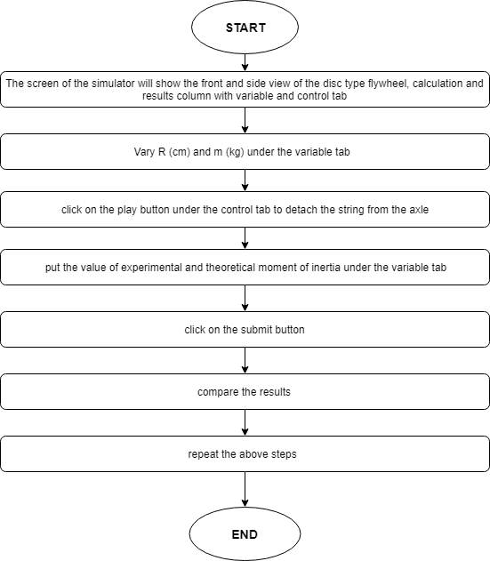

1. **Mindmap:**

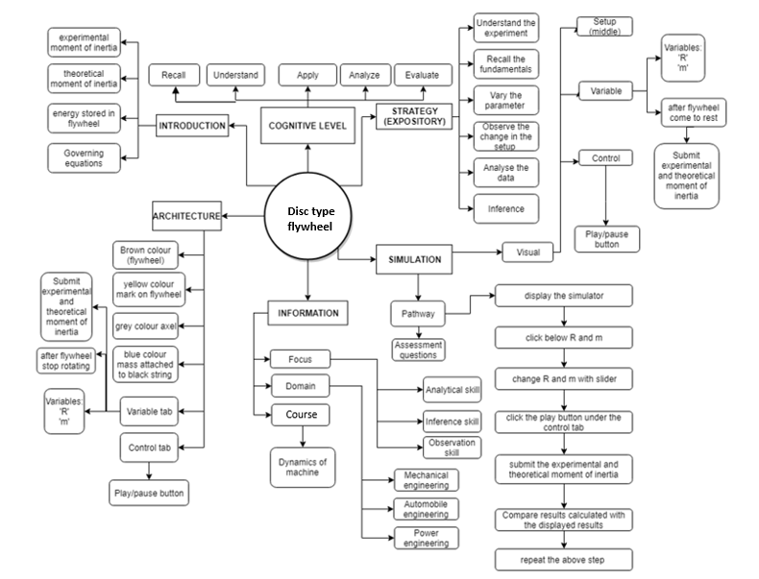

1. **Storyboard:**
   1. In simulation window the experimental setup of the disc type flywheel with a string attached to the axle with mass is shown in front and side view.

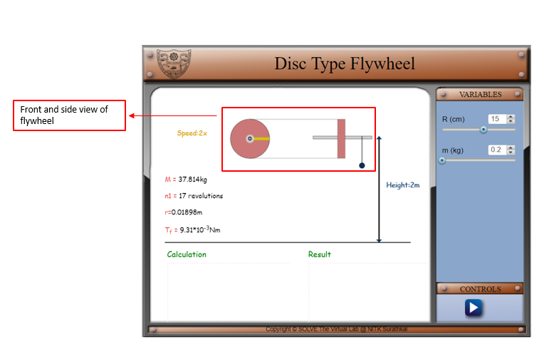

* 1. There are pointers given on right side of the screen for choosing the values of input variables, viz., radius if the disc type flywheel (R) and mass of the metal bob (m). there is a play/pause button under control tab for staring the experiment. The information about the experimental setup is given under the experimental setup.

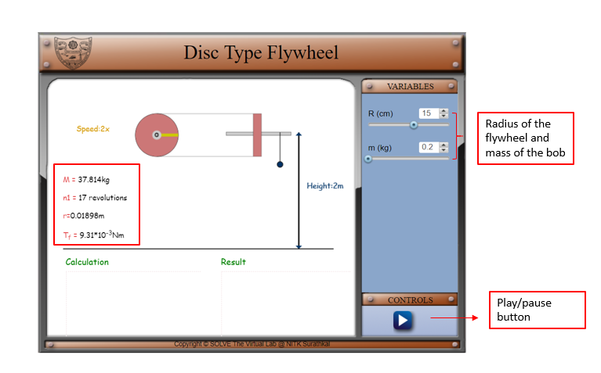

* 1. After initiating the simulation with the help of the play button under the control tab, two option will come under the variable tab to enter the value of experimental and theoretical value of moment of inertia. Under calculation column it will show the time required for bob to touch the ground (t), angular velocity of flywheel at the instant when the mass touches the ground (ω), number of rotations made by the flywheel after the string has left the axle (n2).

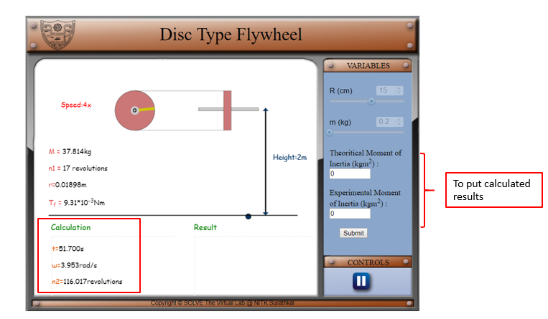

* 1. Click on submit to submit button under variable tab and the correct results will display under the results column with the percentage of error made by the user in calculations.

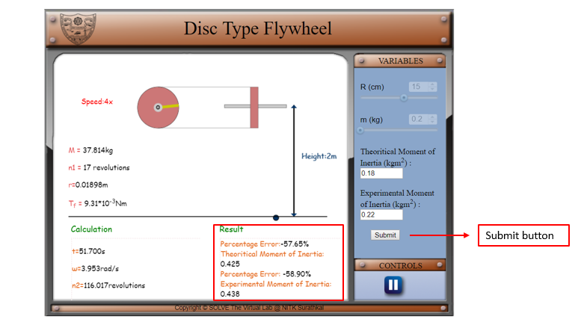

* 1. Compare analytically calculated results and the error in the result with the simulation results, displayed in the bottom of the simulator page.

1. REFERENCE
2. [1] R L Norton- Design of Machinery_ An Introduction to the Synthesis and Analysis of Mechanisms and Machines
3. [2] Theory-of-Machines-14th-ed-Khurmi-2005 (2)
4. [3] <https://nptel.ac.in/courses/122103010/5>